Abstract:
This assignment explores the evolution of the Bengali nationalism movement, tracing its roots from the time of British colonization by the East India Company to the partition of India. The Bengali nationalism movement played a crucial role in shaping the political landscape of the Indian subcontinent and was instrumental in the struggle for independence. This assignment provides an overview of the historical context, key events, prominent figures, and ideologies that influenced the development of Bengali nationalism, ultimately leading to the creation of Bangladesh as a sovereign nation. The research draws upon various primary and secondary sources, including scholarly articles, historical accounts, and government documents, to provide a comprehensive understanding of the subject.
Table of Contents:
Introduction
1.1 Background
1.2 Significance of the Bengali Nationalism Movement
The East India Company and Early Resistance
2.1 British Colonial Rule in Bengal
2.2 Early Opposition and Movements
2.3 Emergence of Bengali Identity
Rise of Political Consciousness: The Swadeshi Movement
3.1 Birth of Indian Nationalism
3.2 Role of Bengal in the Swadeshi Movement
3.3 Impact of Swadeshi on Bengali Nationalism
The Partition of Bengal and the Birth of Bengali Nationalism
4.1 Background of the Partition of Bengal
4.2 Response and Resistance to the Partition
4.3 Formation of Bengali Political Parties
Intellectual Influences and Ideologies
5.1 Rabindranath Tagore and the Bengali Renaissance
5.2 Role of Literature and Language in Shaping Bengali Nationalism
5.3 Influence of Hindu-Muslim Unity Movements
The Bengal Renaissance and Educational Reform
6.1 Cultural Revival and Intellectual Awakening
6.2 Impact of Educational Reform on Bengali Nationalism
6.3 Bengal as a Center of Intellectual Discourse

Role of Bengali Nationalism in the Indian Independence Movement
7.1 Bengal's Contribution to the Non-Cooperation Movement
7.2 Revolutionary Movements and Bengali Nationalism
7.3 Influence of Bengali Nationalism on Other Regions of India
Bengali Nationalism and the Creation of Bangladesh
8.1 Language Movement and the Demand for Autonomy
8.2 Liberation War of Bangladesh
8.3 Birth of Bangladesh as an Independent Nation
Conclusion
9.1 Summary of Key Points
9.2 Impact and Legacy of the Bengali Nationalism Movement
Reference:
1.Chatterjee, Partha. The Nation and Its Fragments: Colonial and Postcolonial Histories. Princeton University Press, 1993.
2.Chaudhuri, Sushil. From Bande Mataram to Jai Hind: Bengal's Quest for Identity, 1905-1947. Sage Publications, 1997.
3.Dutta, Krishna and Andrew Robinson.
Rabindranath Tagore: The Myriad-Minded Man. St. Martin's Press, 1997.
4.Guha, Ranajit.
Dominance Without Hegemony: History and Power in Colonial India. Harvard University Press, 1997.
5.Hasan, Mushirul. Nationalism and Communal Politics in India: The Ideological Dimension. Manohar Publishers, 1991.
6.Islam, Sirajul.
History of Bangladesh, 1704-1971: Eighteenth and Nineteenth Centuries. Asiatic Society of Bangladesh, 1992.
7.Jalal, Ayesha.
The Sole Spokesman: Jinnah, the Muslim League, and the Demand for Pakistan. Cambridge University Press, 1994.
8.Roy, Ananya.
Bengal's Renaissance: Literary, Cultural, and Social Transformation. Routledge, 2003.
9.Sen, Amartya. The Argumentative Indian: Writings on Indian History, Culture, and Identity. Penguin Books, 2005.
10.Sen, Sukumar. History of Bengali Literature. Sahitya Akademi, 1993.

Introduction:
The Bengali nationalism movement emerged in the context of British colonization of the Indian subcontinent. In the late 18th century, the British East India Company gained control over Bengal, which encompassed present-day Bangladesh and the Indian state of West Bengal. The British rule brought significant changes to the social, political, and economic fabric of the region.
Under British colonialism, Bengal witnessed the imposition of policies that had adverse effects on the local population. The exploitative economic policies, land revenue systems, and administrative reforms implemented by the British administration created discontent among the Bengali people. Additionally, the imposition of English as the medium of education and administration marginalized the native Bengali language and culture.
Significance of the Bengali Nationalism Movement
The Bengali nationalism movement holds immense significance in the history of the Indian subcontinent. It was a crucial force in shaping the political landscape of the region and played a pivotal role in the struggle for independence from British colonial rule. The movement sought to assert the distinct identity and rights of the Bengali people, fighting against various forms of oppression and exploitation.
The Bengali nationalism movement not only aimed at achieving political autonomy but also focused on cultural and linguistic revitalization. It emphasized the importance of preserving and promoting the rich Bengali language, literature, and cultural heritage, which had been undermined under British rule.
The movement's emphasis on self-governance, resistance against colonial policies, and fostering unity among diverse communities laid the foundation for a broader Indian nationalistic consciousness.
Ultimately, the Bengali nationalism movement culminated in the partition of India and the creation of Bangladesh as an independent nation.
The significance of the Bengali nationalism movement extends beyond the historical context. It continues to shape the socio-political dynamics of Bangladesh and West Bengal, influencing notions of identity, language, culture, and governance.

The East India Company and Early Resistance
British Colonial Rule in Bengal
The British East India Company arrived in Bengal in the late 18th century and gradually established its control over the region. Bengal, with its prosperous economy, fertile land, and strategic location, became a crucial center of British colonial administration in India.
Under British rule, Bengal experienced significant changes in its socio-economic and political landscape. The East India Company implemented exploitative economic policies, such as the Permanent Settlement System, which imposed heavy land taxes on peasants and caused widespread agrarian distress.
Early Opposition and Movements
The early years of British colonial rule in Bengal witnessed resistance and opposition from various quarters. The Bengali population, particularly the zamindars (landlords) and intellectuals, were deeply impacted by the economic and cultural changes
brought about by British rule. They started voicing their concerns and organizing movements against colonial policies.
One significant early movement was the Fakir-Sannyasi Rebellion in the late 18th century. It was led by religious figures known as Fakirs and Sannyasis, who mobilized the rural population against British oppression and economic exploitation.
These early movements reflected the growing discontent and resistance among the Bengali population against British colonialism. They laid the foundation for subsequent nationalist movements and struggles for self-determination.
Emergence of Bengali Identity
The early resistance against British colonial rule in Bengal played a significant role in the emergence and shaping of Bengali identity. As the Bengali population experienced the social, economic, and cultural disruptions brought about by British rule, they started developing a distinct consciousness of their collective identity.
The Bengali language, with its rich literary heritage, became a focal point of cultural pride and resistance against the dominance of English. Scholars and intellectuals like Raja Ram Mohan Roy and Ishwar Chandra Vidyasagar played a crucial role in promoting the Bengali language and literature and fostering a sense of linguistic and cultural identity among the Bengali people.
Overall, the early resistance against British colonial rule in Bengal contributed to the emergence of a distinct Bengali identity. The struggles against economic exploitation, cultural marginalization, and the imposition of foreign languages laid the groundwork for the subsequent nationalist movements and the assertion of Bengali self-determination.

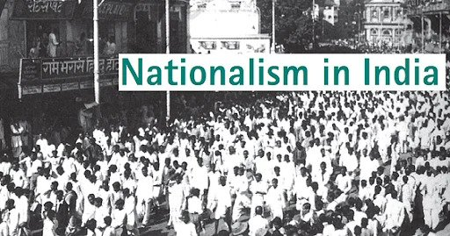
Rise of Political Consciousness: The Swadeshi Movement
Birth of Indian Nationalism
The Swadeshi Movement emerged in response to the partition of Bengal in 1905 and aimed to promote indigenous industries, boycott British goods, and encourage the use of Indian-made products. It played a pivotal role in the birth of Indian nationalism and the evolution of Bengali nationalism. The movement sought economic self-reliance, emphasizing the importance of Indian goods and industries to strengthen the nation's economy. It quickly gained momentum and became a significant force in the fight against British colonial rule.
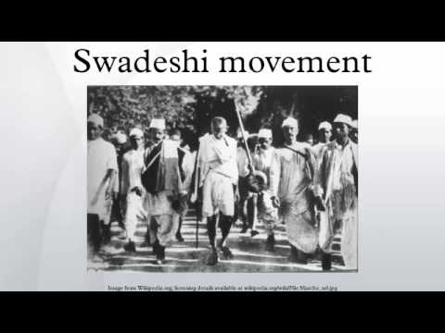

Role of Bengal in the Swadeshi Movement
Bengal played a significant role in the Swadeshi Movement. It was in Bengal that the movement emerged in response to the partition of the province by the British in 1905. The Bengali people actively participated in promoting indigenous industries, boycotting British goods, and advocating for economic self-reliance. Bengal became a stronghold of the Swadeshi Movement and played a pivotal role in shaping Indian nationalism during that time.
Impact of Swadeshi on Bengali Nationalism
The Swadeshi Movement had a profound impact on Bengali nationalism. It played a pivotal role in the evolution and strengthening of Bengali nationalism. The movement united the Bengali people in their fight against British colonial rule and the unjust partition of Bengal. It instilled a sense of pride in indigenous industries and products, promoting economic self-reliance and self-sufficiency. The Swadeshi Movement served as a catalyst for the growth of Bengali identity and nationalist sentiments, shaping the course of Bengali nationalism in the years to come.

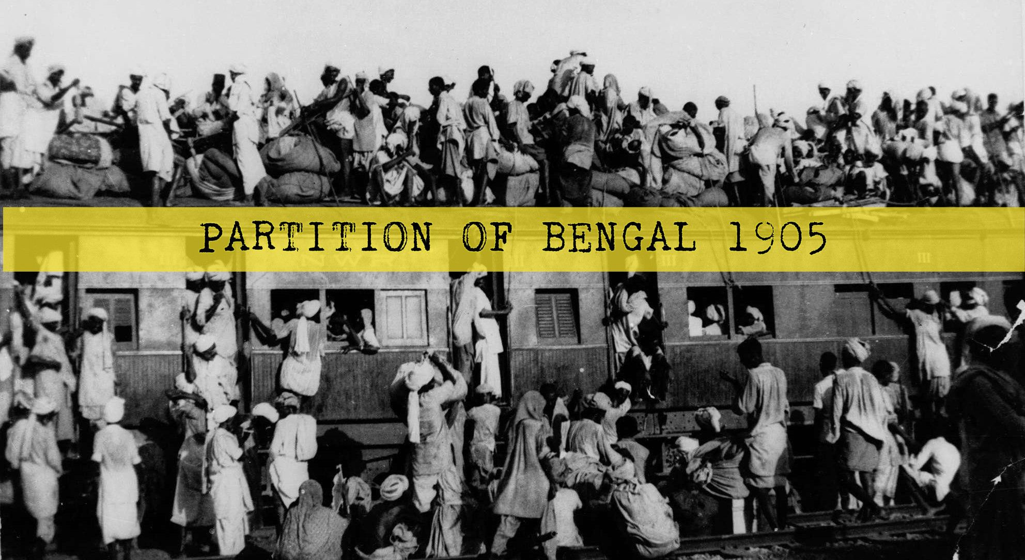
The Partition of Bengal and the Birth of Bengali Nationalism

Background of the Partition of Bengal
The partition of Bengal occurred in 1905 and was a deliberate decision by the British government. It aimed to divide the province along religious lines, creating separate Hindu and Muslim majority regions. The partition was seen as a strategy to weaken the growing nationalist movement in Bengal by sowing division between Hindus and Muslims. This move sparked widespread protests and resistance, leading to the emergence of the Swadeshi Movement and fueling the growth of Indian nationalism.
Response and Resistance to the Partition
The partition of Bengal sparked widespread protests and resistance, including civil disobedience, boycotts, and acts of non-cooperation. People from various backgrounds, including students, intellectuals, women, and workers, actively participated in the movement against the partition. The protests were marked by inclusivity, with people from different religions and social strata coming together. The Swadeshi Movement, with its boycott of British goods and promotion of Indian industries, became a prominent form of protest against the partition and British colonial rule..
Formation of Bengali Political Parties
The partition of Bengal led to the formation of political parties that played a vital role in advancing Bengali nationalism. The Indian National Congress (INC) and organizations like the Anushilan Samiti and Jugantar emerged during this period. The INC became a unifying force, while revolutionary organizations focused on armed resistance. These parties provided platforms for mobilization, coordination, and ideological discussions. The formation of these political parties marked a shift towards organized political strategies, strengthening the Bengali nationalism movement and its quest for self-determination and independence.

Intellectual Influences and Ideologies
Rabindranath Tagore and the Bengali Renaissance
Rabindranath Tagore, a renowned intellectual and cultural figure in Bengal, played a significant role in shaping Bengali nationalism during the Bengal Renaissance. As a poet, philosopher, and social reformer, Tagore's ideas and works had a profound impact on the intellectual climate of the time. He emphasized the preservation and promotion of Bengali language, literature, and cultural heritage, evoking a sense of pride and love for Bengal and its traditions.
Tagore's vision of universalism, humanism, and spiritual harmony also influenced the nationalist discourse in Bengal. His concept of "Brahma Samaj," advocating for the unity of all religions and the importance of ethical principles, resonated with the inclusive and pluralistic nature of Bengali nationalism.
Role of Literature and Language in Shaping Bengali Nationalism
Literature and language played crucial roles in shaping Bengali nationalism. Writers such as Bankim Chandra Chattopadhyay, Sarat Chandra Chattopadhyay, and Kazi Nazrul Islam used their literary works to express nationalist ideas and resistance against British imperialism. Novels, poems, and plays became vehicles for portraying the struggles and aspirations of the Bengali people, fostering solidarity and pride in their cultural identity.
The Bengali language, marginalized under British rule, became a symbol of resistance and assertion of Bengali identity. Efforts were made to promote Bengali as a medium of education, administration, and literature. The establishment of educational institutions, literary societies, and publishing houses in Bengal played a crucial role in developing and disseminating nationalist ideas and literature.
Influence of Hindu-Muslim Unity Movements
The movements for Hindu-Muslim unity in Bengal had a significant influence on Bengali nationalism. Leaders like Nawab Salimullah Khan, Syed Ahmad Khan, and A.K. Fazlul Huq fostered cooperation between the Hindu and Muslim communities, challenging the British administration's divisive tactics. These movements emphasized the shared history, cultural heritage, and socio-political aspirations of both communities, promoting a united front against colonial rule. Hindu-Muslim unity in Bengal laid the foundation for the inclusive and pluralistic nature of Bengali nationalism.

The Bengal Renaissance and Educational Reform
Cultural Revival and Intellectual Awakening
The Bengal Renaissance, characterized by cultural and intellectual revival, played a crucial role in shaping the evolution of Bengali nationalism. Prominent figures such as Raja Ram Mohan Roy, Dwarkanath Tagore, and Ishwar Chandra Vidyasagar spearheaded efforts to reform society, challenge orthodox practices, and promote scientific thinking. Education, combining the best of Western and indigenous knowledge, became instrumental in empowering individuals and uplifting society. Educational institutions like Hindu College, Sanskrit College, and Bethune College provided platforms for intellectual discourse and the dissemination of nationalist ideas.

Impact of Educational Reform on Bengali Nationalism
Educational reform during the Bengal Renaissance had a significant impact on the evolution of Bengali nationalism. The emphasis on education and the spread of Western knowledge created an educated class of Bengalis who became the vanguard of the nationalist movement. The new education system nurtured political consciousness, critical thinking, and awareness of democratic values among Bengali youth. Educational institutions became centers of nationalist activities and ideological discussions, incorporating subjects related to Indian history, culture, and nationalist movements, fostering a sense of pride and belonging among the students.
Bengal as a Center of Intellectual Discourse
Bengal emerged as a vibrant center of intellectual discourse during the Bengal Renaissance. Educational institutions, literary societies, and cultural gatherings provided spaces for intellectuals, scholars, and artists to engage in discussions and debates on social, political, and cultural issues. Scholars and thinkers like Rabindranath Tagore, Bankim Chandra Chattopadhyay, and Ishwar Chandra Vidyasagar shaped the narrative of Bengali nationalism through their writings, speeches, and intellectual contributions. Bengal's rich intellectual heritage, combined with socio-cultural reforms and educational advancements, made it a hub of progressive ideas and nationalist movements, contributing to the growth and maturation of Bengali nationalism.
Role of Bengali Nationalism In the Indian Independence Movement
Bengal's Contribution to the Non- Cooperation Movement
Bengali nationalism played a significant role in the Indian independence movement, especially during the Non-Cooperation Movement led by Mahatma Gandhi in the1920s.
The Non-Cooperation Movement called for boycotting British institutions, including educational institutions, law courts, and government services. In Bengal, the movement gained widespread support and participation from various sections of society. Students and lawyers actively participated. People abstain from using British-made goods.
Bengal's contribution to the Non-Cooperation Movement was characterized by mass mobilization, public demonstrations, and acts of civil disobedience. Leaders like Subhash Chandra Bose, Surendranath Banerjee, and Chittaranjan Das played instrumental roles in organizing and leading the movement in Bengal.
Revolutionary Movements and Bengali Nationalism
Bengal witnessed the emergence of revolutionary movements fueled by AnushilanSamiti and Jugantar like organizations, which aimed to achieve independence through armed struggle against British rule.
Influenced by Swami Vivekananda, Bankim Chandra Chattopadhyay, and Sri Aurobindo, Bengali nationalists sought to combine spirituality, cultural revival, and political activism. These movements carried out activities such as assassinations, bombings, and sabotage.
Though they did not achieve immediate independence, they inspired future generations of freedom fighters and kept the spirit of resistance alive.
Influence of Bengali Nationalism on Other Regions of India
Bengali nationalism had a significant influence on the nationalist movements in other regions of India. The ideals, strategies, and sacrifices of Bengali nationalists served as an inspiration for freedom fighters across the country.
The ideas of Swadeshi, boycott, and cultural revival propagated by the Bengali nationalists found resonance in other parts of India. The call for self-reliance, promotion of indigenous industries, and the revival of cultural heritage became central themes in the nationalist movements in different regions.
The partition of Bengal in 1905 and the subsequent resistance and activism against it also served as a catalyst for the growth of nationalist movements in other provinces. Leaders like Surendranath Banerjee, Subhash Chandra Bose, and Aurobindo Ghoshplayed pivotal roles in shaping the nationalist discourse and strategies of the Congress. Their ideas and actions influenced the broader Indian nationalist movement.
In conclusion, It is important to note that while Bengali nationalism has had an influence on other regions of India, the nationalist movements in these regions also had their distinct characteristics and aspirations. The exchange of ideas and ideologies across regions contributed to the broader Indian national movement, which aimed at securing independence and building a united and diverse nation.
Bengali Nationalism and the Creation Of Bangladesh Language Movement and the Demand for Autonomy
The 1952 Language Movement was pivotal for Bengali nationalism and led to the creation of Bangladesh. It arose against the imposition of Urdu as the sole state language of Pakistan, disregarding the Bengali-speaking majority in East Pakistan. The movement demanded recognition of Bengali as a state language, resulting in widespread protests, strikes, and civil disobedience. It represented the Bengali people's resistance against cultural and linguistic oppression, seeking autonomy and recognition.
The Language Movement became a unifying force for the Bengali people, transcending religious, social, and political boundaries. It brought together students, intellectuals, and common people in their fight for linguistic rights and cultural identity.
Liberation War of Bangladesh
The 1971 Liberation War of Bangladesh was the culmination of Bengali nationalism and the fight for autonomy. It arose from the marginalization of East Pakistan and suppression of Bengali identity by the Pakistani government. Years of economic disparities, political repression, and cultural alienation fueled the sentiment of Bengali nationalism. The Awami League, led by Sheikh Mujibur Rahman, became the primary political force advocating for autonomy and recognition of Bengali identity. The Pakistani military responded with a brutal crackdown, resulting in widespread atrocities, violence, and displacement. In response, supported by India, Bengali nationalists organized a resistance movement to assert their right to self- determination. The nine-month-long Liberation War witnessed fierce battles, guerrilla warfare, and diplomatic efforts. The Bengali nationalist forces, known as the Mukti Bahini, with the support of the Indian Armed Forces, eventually defeated the Pakistani military, leading to the establishment of an independent Bangladesh.
Birth of Bangladesh as an Independent Nation
On December 16, 1971, Bangladesh emerged as an independent nation, fulfilling the long-standing aspirations of Bengali nationalists. It represented their quest for self- determination, cultural recognition, and political autonomy. The birth of Bangladesh Inspired other nationalist movements globally, showcasing the strength of collective resistance and marginalized populations' determination to achieve their goals. Bengali nationalism played a pivotal role in shaping Bangladesh's national identity, cultural values, and political institutions. The struggle for linguistic rights and autonomy laid the groundwork for a democratic and inclusive society that cherishes language, culture, and diversity.
In conclusion, Bengali nationalism had a profound impact on the Indian independence movement, influencing the strategies, ideologies, and aspirations of freedom fighters. It contributed to the Non-Cooperation Movement, inspired revolutionary movements, and influenced nationalist movements in other regions of India. Moreover, Bengali nationalism ultimately led to the creation of Bangladesh, marking a significant chapter in the history of the nationalist movement.
Conclusion:
Summary of Key Points
The Bengali nationalism movement evolved from early opposition to British colonial rule to the partition of Bengal and the emergence of political parties. The Swadeshi movement and Language Movement played significant roles in igniting political consciousness and demanding linguistic and cultural recognition. Intellectual influences, such as Rabindranath Tagore, and the Bengal Renaissance revitalized Bengali culture and shaped the movement's ideologies. Bengali nationalism made substantial contributions to the Indian independence movement, advocating for Hindu-Muslim unity and inspiring struggles for autonomy. The movement's impact and legacy are profound, culminating in the creation of Bangladesh and shaping the socio-political dynamics of the region.
Impact and Legacy of the Bengali Nationalism Movement
The impact and legacy of the Bengali nationalism movement are significant. The movement's emphasis on autonomy and self-determination paved the way for the creation of Bangladesh as an independent nation, fulfilling the aspirations of the Bengali people for self-governance and cultural recognition. The movement's influence extended beyond Bengal, shaping the broader Indian nationalist movement and inspiring struggles for autonomy and cultural rights in other regions. It left a lasting imprint on the political ideologies, governance systems, and cultural practices of Bangladesh and West Bengal.
The legacy of the movement can be seen in the preservation and promotion of Bengali language, literature, and cultural heritage, which continue to be important elements of the region's identity. The movement's commitment to democratic values, inclusivity, and resistance against oppression remains relevant in contemporary debates on nationalism and identity.
Furthermore, the ideas, strategies, and leaders that emerged from the Bengali nationalism movement continue to inspire and shape the socio-political dynamics of the region. The movement's legacy serves as a reminder of the enduring struggle for freedom and the power of collective action in shaping the destiny of nations.

